Project Development Phase
Model Performance Test

Team ID | SWTID-2026-7899
Project Name | Auto Ticket Classification using Flow Designer
Maximum Marks

Model Performance Testing:
Project team shall fill the following information in model performance testing template.
S.No. | Parameter | Values | Screenshot
 | Model Summary | Rule-based keyword classification built with ServiceNow Flow Designer (no ML model is trained).  Table: School IT ticket (u_school_it_ticket) – Number, Caller, Category, Subcategory, Short Description, Description, State, Assigned Group, Assigned to.  Flow: Auto Classify School IT Tickets – triggers on Record Created when Category is empty.  Rules (Short Description contains): Wi-Fi / Network → Network, Wi-Fi; Projector → Hardware, Projector; Forgot password → Access, Forgot Password; Slow computer → Performance, Slow Computer.  Action: Update Record, then Send Email to the caller. | 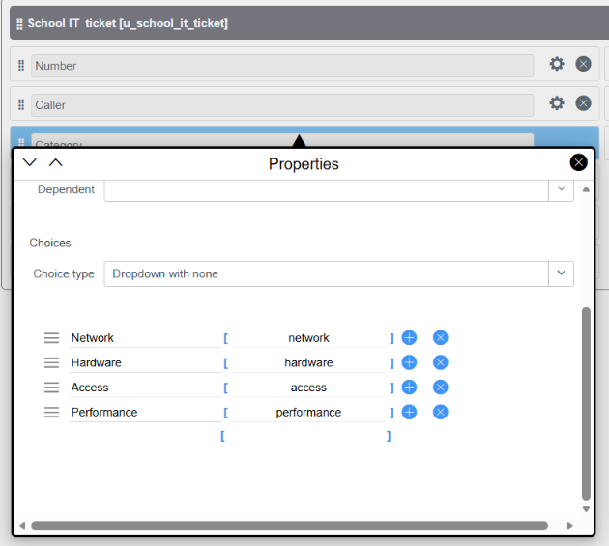  Fig 1 – Form Design – Category choices on School IT ticket [u_school_it_ticket]  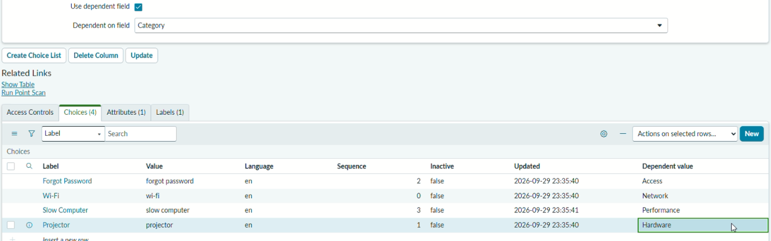  Fig 2 – Subcategory dependent on Category (dependent values)
 | Accuracy | Training Accuracy – Not applicable (rule-based logic, no model training).  Validation Accuracy – Test ticket SCH0001006 (Short Description: “Network issue”) was classified as Category = Network, Subcategory = Wi-Fi, as expected (1 of 1 tested). The flow also sent the confirmation email “Your Request for the issue has been submitted” to the caller. | 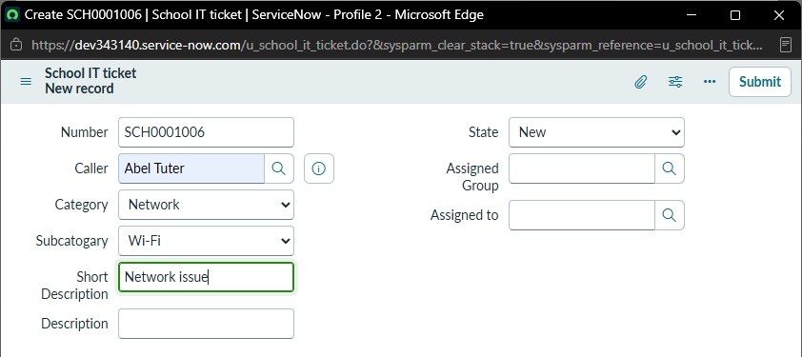  Fig 3 – Test ticket SCH0001006: “Network issue” → Network / Wi-Fi  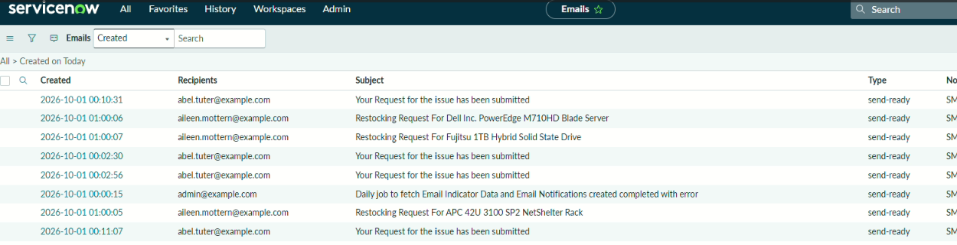  Fig 4 – Emails log – confirmation email sent to caller
 | Fine Tunning Result( if Done) | Validation Accuracy – Not applicable (no ML model to fine-tune).  Refinement done: Subcategory is dependent on Category, so only valid options are shown (Network → Wi-Fi, Hardware → Projector, Access → Forgot Password, Performance → Slow Computer). Filtering verified for Network, Hardware and Performance; all 4 mappings are listed in Fig 2. | 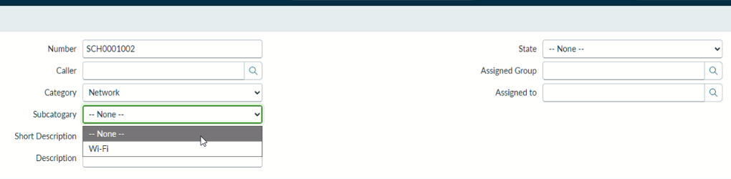  Fig 5 – Category = Network → only Wi-Fi offered  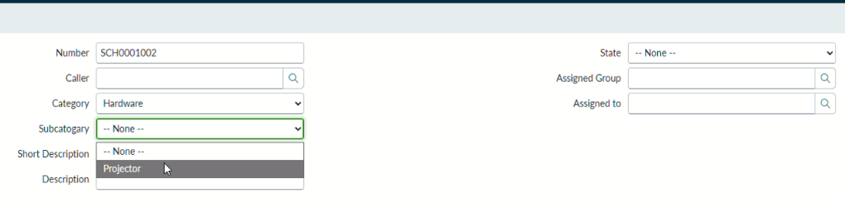  Fig 6 – Category = Hardware → only Projector offered  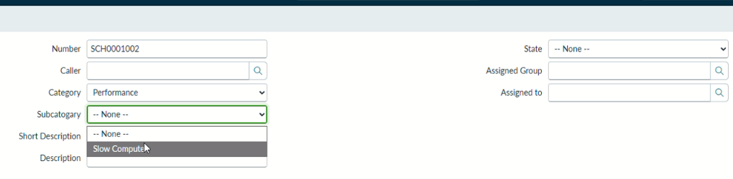  Fig 7 – Category = Performance → only Slow Computer offered

